Given a binary tree, print nodes of extreme corners of each level but in alternate order.

Example:  
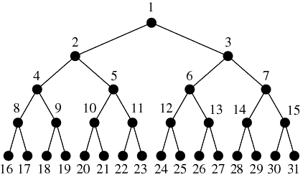

For above tree, the output can be

**1 2 7 8 31**  
– print rightmost node of 1st level  
– print leftmost node of 2nd level  
– print rightmost node of 3rd level  
– print leftmost node of 4th level  
– print rightmost node of 5th level

OR

**1 3 4 15 16**  
– print leftmost node of 1st level  
– print rightmost node of 2nd level  
– print leftmost node of 3rd level  
– print rightmost node of 4th level  
– print leftmost node of 5th level

# Check if a given Binary Tree is SumTree

Write a function that returns true if the given Binary Tree is SumTree else false. A SumTree is a Binary Tree where the value of a node is equal to sum of the nodes present in its left subtree and right subtree. An empty tree is SumTree and sum of an empty tree can be considered as 0. A leaf node is also considered as SumTree.

Following is an example of SumTree.

26

/ \

10 3

/ \ \

4 6 3

Given a Binary Tree find the length of the longest path which comprises of nodes with consecutive values in increasing order. Every node is considered as a path of length 1.

Examples:

10

/ \

/ \

11 9

/ \ /\

/ \ / \

13 12 13 8

Maximum Consecutive Path Length is 3 (10, 11, 12)

Note: 10, 9 ,8 is NOT considered since

the nodes should be in increasing order.

5

/ \

/ \

8 11

/ \

/ \

9 10

/ /

/ /

6 15

Maximum Consecutive Path Length is 2 (8, 9).

Maximum width of a binary tree

Given a binary tree, write a function to get the maximum width of the given tree. Width of a tree is maximum of widths of all levels.

Let us consider the below example tree.

1

/ \

2 3

/ \ \

4 5 8

/ \

6 7

For the above tree,  
width of level 1 is 1,  
width of level 2 is 2,  
width of level 3 is 3  
width of level 4 is 2.

So the maximum width of the tree is 3.

# Convert a given tree to its Sum Tree

Given a Binary Tree where each node has positive and negative values. Convert this to a tree where each node contains the sum of the left and right sub trees in the original tree. The values of leaf nodes are changed to 0.

For example, the following tree

10

/ \

-2 6

/ \ / \

8 -4 7 5

should be changed to

20(4-2+12+6)

/ \

4(8-4) 12(7+5)

/ \ / \

0 0 0 0